# Media Analysis - AI is not smarter than humans _ Updated 08 April 2023

## Short Summary

The article is about the capabilities and limitations of artificial intelligence AI in enhancing personal and business tasks, emphasizing that while AI offers significant advancements and conveniences, it cannot replace human creativity, cultural understanding, or emotional connection, illustrated through examples like Apple s Siri and Microsoft s Tay.

## Summary

- AI tools, like ChatGPT, have become valuable for personal and business tasks by offering assistance akin to real-life recruiters or marketers, thanks to skilled engineers.  
- While AI can aid with grammar and brainstorming ideas, its reliability and human-like understanding of culture are still limited, as shown when Microsoft's chatbot Tay was misused shortly after release.  
- Although AI is praised for enhancing business operations and marketing, it cannot fully capture cultural nuances or replace the essential human connection in crafting meaningful experiences.  
- AI continues to evolve, facilitating communication across languages with tools like Google Translate, yet emphasizes that personalized messaging remains rooted in human input.

## Question 1

The text does not explicitly address how the media frames public discussions about AI, such as ChatGPT. Instead, it provides a personal perspective on AI's role in enriching personal and business tasks. The author expresses advocacy for AI tools due to their practical applications but highlights limitations, like cultural understanding. Tay's example illustrates concerns over AI reliability when exposed to negative input. Although not framed within media metaphors, the text touches on themes of AI as a tool for enhancing human capabilities while emphasizing its current limitations and the irreplaceability of human connection.  
  
Key points from the text include:  
- **Practical Uses**: AI is seen as beneficial in managing tasks, such as setting reminders or assisting with brainstorming.  
- **Advocacy**: The author supports AI due to its effectiveness in certain areas but acknowledges it cannot replace human nuance and emotional depth.  
- **Limitations**: Instances like Tay highlight potential issues with AI's reliability and the risks of negative influence.  
- **Human Connection**: Despite technological advancements, human interaction remains essential for personalized and culturally rich communication.

## Question 2

### Perspectives and Aspects Covered:  
  
1. **Advantages of AI:**  
 - Enrichment of personal life and business tasks.  
 - Role as virtual assistants for reminders and brainstorming ideas.  
 - Boost in self-confidence and communication skills.  
  
2. **Technological Progression:**  
 - Evolution from simple voice-activated devices like Siri to more advanced applications.  
 - Integration of AI in various industries, such as marketing and recruitment.  
  
3. **Potential and Limitations:**  
 - AI’s potential to revolutionize industries similar to the internet's impact.  
 - Incidents highlighting vulnerabilities (e.g., Tay's misuse).  
 - Understanding culture and emotions beyond data capabilities.  
  
4. **Human-AI Relationship:**  
 - Importance of human connection in tailoring personalized content.  
 - Language barriers bridged by AI, yet acknowledging its limitations.  
  
5. **Future Prospects:**  
 - Expansion to multiple languages for broader communication.  
 - Emphasis on the irreplaceability of humans despite technological advances.  
  
### Aspects Ignored:  
  
1. **Ethical Considerations:**  
 - Privacy concerns related to AI usage are not addressed.  
   
2. **Economic Impact:**  
 - Potential job displacement due to increased automation is not discussed.  
  
3. **Regulatory Challenges:**  
 - The need for policies and regulations governing AI development and deployment is overlooked.  
  
4. **Technical Limitations:**  
 - In-depth discussion on the current technical constraints of AI technologies is missing.  
  
5. **Social Implications:**  
 - Broader social impacts, such as inequality in technology access, are not covered.  
  
Overall, while the text provides a comprehensive view of the benefits and limitations of AI, it omits discussions on ethical, economic, regulatory, technical, and broader social implications.

## Question 3

Not mentioned.  
  
The text discusses AI's impact on personal life, business tasks, and general advancements but does not specifically mention or address how the Arabic world leverages AI.

## Question 4

The final message of the article emphasizes that while AI can significantly enhance personal and business tasks by providing innovative ideas and solutions, it cannot replace the essential human connection or fully grasp cultural nuances. Despite its growing influence, AI's role remains supportive, augmenting human capabilities rather than replacing them. The author advocates for a balanced relationship with AI, recognizing both its potential and limitations.

## Sentiment

The sentiment is 3.0

## Entities

Saint Marys University, Twitter, Microsoft, Tay, Google Translate, Saleh, Ali Al-Mustafa, Apple, SAP, Oracle

## Highlights

#7cc867: 29

#fb5b89: 29

#f9cd59: 19

## Wordcloud for #7cc867 Highlights

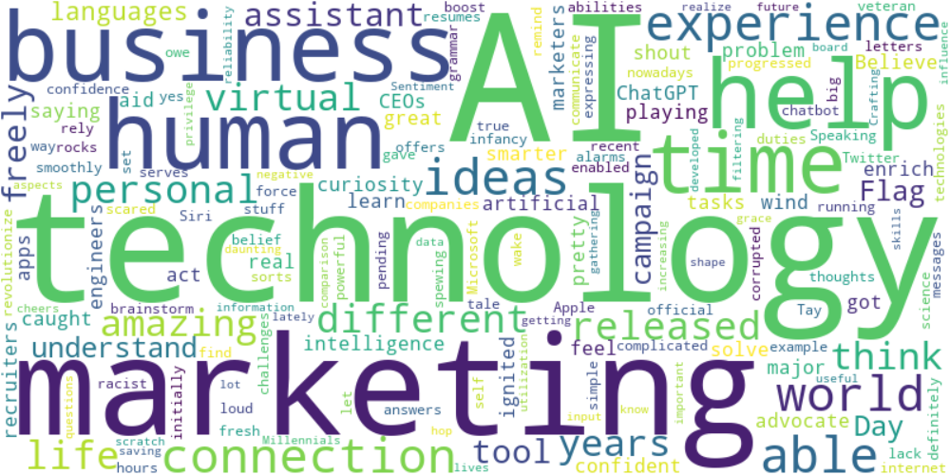

Top 10 words:

- AI: 10

- technology: 8

- marketing: 6

- like: 5

- business: 4

- humans: 3

- experience: 3

- able: 3

- ideas: 3

- connection: 3

## Wordcloud for #fb5b89 Highlights

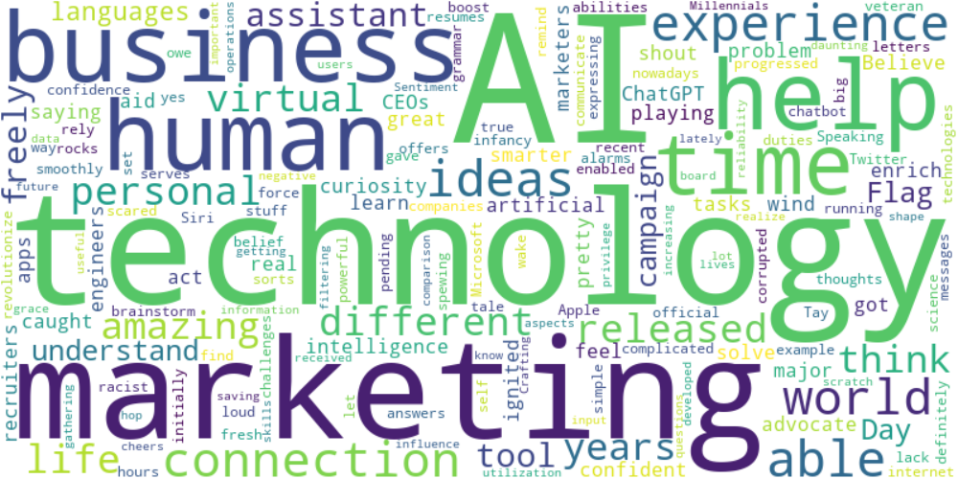

Top 10 words:

- AI: 10

- technology: 8

- marketing: 6

- like: 5

- business: 4

- humans: 3

- experience: 3

- able: 3

- ideas: 3

- connection: 3

## Wordcloud for #f9cd59 Highlights

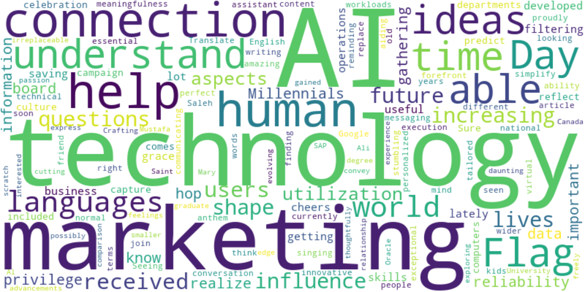

Top 10 words:

- AI: 6

- technology: 5

- marketing: 4

- connection: 3

- help: 3

- like: 2

- humans: 2

- understand: 2

- able: 2

- ideas: 2